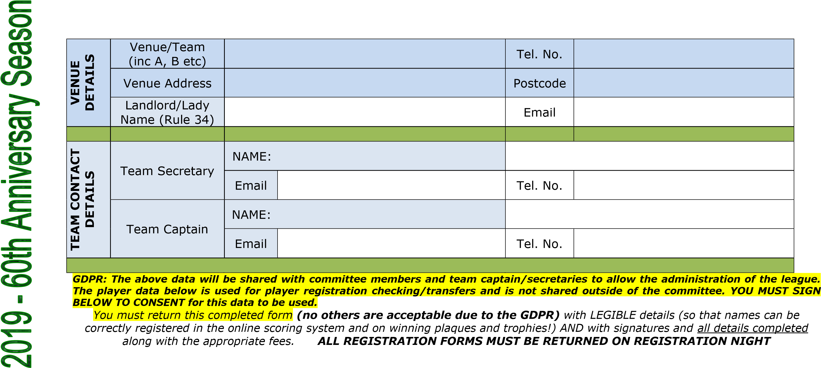
ABINGDON AND DISTRICT AUNT SALLY LEAGUE 2020 TEAM REGISTRATION FORM Team No._____
£40 entry per team up to 14 players
Any registered players in excess of 14 an additional £1.00 each

 | PLAYERS MUST SIGN TO CONSENT TO REGISTRATION UNDER GDPR |  |  |  | OFFICIAL USE ONLY Avg/PNo
PRINT Player First name | PRINT Player Surname | Players Signature | Home Address | Previous Team played for
1

2

Entry to the league will require online entry of scorecards.

ABINGDON AND DISTRICT AUNT SALLY LEAGUE 2020 TEAM REGISTRATION FORM Team No._____
 | PLAYERS MUST SIGN TO CONSENT TO REGISTRATION UNDER GDPR |  |  |  | OFFICIAL USE ONLY Avg/PNo
PRINT Player First name | PRINT Player Surname | Players Signature | Home Address | Previous Team played for
3
4
5
6
7
8
9
10
11
12
13
14
15

This form can be downloaded from the website
Entry to the league will require online entry of scorecards.

